- a new release once every 2+ months, and several stable and extended stable releases once a week.

- A new release comes out once every 10 to 11 weeks. Releases are time-based rather than feature-based.

- Linus Torvalds releases a new kernel and opens a 2-week merge window. During this merge window, he pulls code for the next release from subsystem maintainers. Subsystem maintainers send signed git pull requests to Linus either during the merge window or before. All major new development is added to the kernel during the merge window.10,000+ change sets (patches) get pulled into Linus's tree during these 2 weeks, at the end of which he releases the first release candidate, known as rc1.

At this point, the release cycle moves into a bug fixes-only mode, with a series of release candidate (rc) releases from Linus. One week after rc1 is released, rc2 comes out; rc3 comes out a week after, and so on, until all major bug fixes and regressions (if any) are resolved.

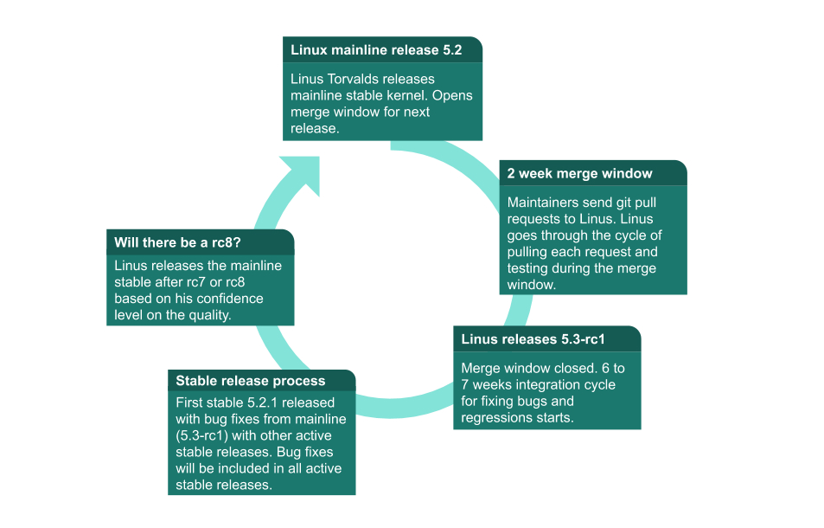

Release Candidate (RC)
Release Candidate or RC releases are mainline kernel pre-releases that are used for testing new features in the mainline

Stable
Stable releases are bug fix-only releases. After Linus releases a mainline kernel, it moves into stable mode. Any bug fixes for a stable kernel are backported from the mainline kernel and applied to stable git by a designated stable kernel release maintainer.

Long-term
Long-term releases are stable releases selected for long-term maintenance to provide critical bug fixes for older kernel trees.

Patches for the next release may be added to linux-next after the merge window has closed, and the rc1 candidate has been released by Linus.

Each major subsystem has its own tree and designated maintainer(s). Subsystems may have multiple maintainers. You can find a list of subsystems and their maintainers in the MAINTAINERS file in the kernel source.

Contributors send patches to mailing lists through email, and contributions are then discussed through emails. Most maintainers send an email response to contributors saying "Applied to tree-name" or "Thanks Applied" to contributors when they accept and commit patches.

